Report on COVID-19 Tweet Sentiment Analysis using Machine Learning

1. Introduction
Social media platforms like Twitter have played a major role in spreading information and public opinion during the COVID-19 pandemic. People expressed emotions such as fear, hope, anger, and support through tweets. Sentiment analysis is a Natural Language Processing (NLP) technique that helps classify such opinions into categories like positive, neutral, and negative.
This project focuses on analyzing COVID-19 tweets and classifying them into sentiment categories using machine learning algorithms.

2. Objective
The objectives of this project are:
- To use a COVID-19 tweets dataset obtained from Kaggle.
- To classify tweets into Positive, Neutral, and Negative sentiments.
- To split the dataset into 80% training and 20% testing.
- To apply machine learning classifiers:
  - Naïve Bayes
  - Support Vector Machine (SVM)
  - Logistic Regression
- To evaluate models using:
  - Precision
  - Recall
  - F1-score
  - Accuracy
- To compare the performance of all models and identify the best model.

3. Dataset Description
The dataset used in this project was obtained from Kaggle and contains COVID-19 related tweets. The dataset consists of 100 tweets, labeled into sentiment categories.

Dataset Source:
Kaggle COVID-19 Tweets Dataset
Dataset Columns:
- tweets: Tweet text
- sentiment: Sentiment label (positive / neutral / negative)
Sample Data:
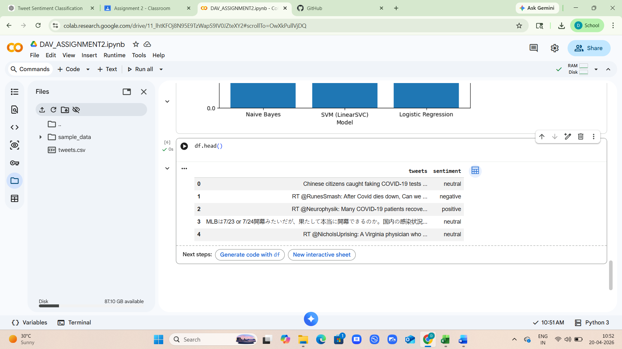
4. Methodology

4.1 Data Preprocessing
The following preprocessing steps were performed:
- The dataset was loaded using Pandas.
- Null/missing values were removed.
- Text features were extracted using TF-IDF vectorization.

4.2 Train-Test Split
The dataset was split into:
- 80 tweets for training
- 20 tweets for testing
Stratified splitting was used to maintain sentiment distribution.

4.3 Feature Extraction using TF-IDF
TF-IDF (Term Frequency – Inverse Document Frequency) converts text into numeric feature vectors and gives higher weight to important words.
TF-IDF was applied using:
TfidfVectorizer(stop_words="english")

5. Machine Learning Models Used
5.1 Naïve Bayes Classifier
Naïve Bayes is a probability-based classification algorithm based on Bayes theorem. It is commonly used for text classification because it performs well on word frequency-based datasets.

5.2 Support Vector Machine (SVM)
SVM is a supervised learning algorithm that separates classes using an optimal hyperplane. It works effectively for high-dimensional text data.
5.3 Logistic Regression
Logistic Regression is a classification algorithm that predicts probabilities of different classes. It is widely used for sentiment analysis due to its efficiency and accuracy.

6. Evaluation Metrics
The models were evaluated using the following metrics:

6.1 Precision
Precision measures how many predicted labels were correct.
$$Precision=\frac{TP}{TP+FP}$$

6.2 Recall
Recall measures how many actual labels were correctly identified.
$$Recall=\frac{TP}{TP+FN}$$

6.3 F1-Score
F1-score is the harmonic mean of precision and recall.
$$F1=\frac{2×Precision×Recall}{Precision+Recall}$$

6.4 Accuracy
Accuracy measures the percentage of correctly classified tweets.
$$Accuracy=\frac{CorrectPredictions}{TotalPredictions}$$

7. Results and Discussion
After training and testing the models, the performance was calculated. The comparison was done using macro-average precision, recall, and F1-score.

7.1 Classification Report Output

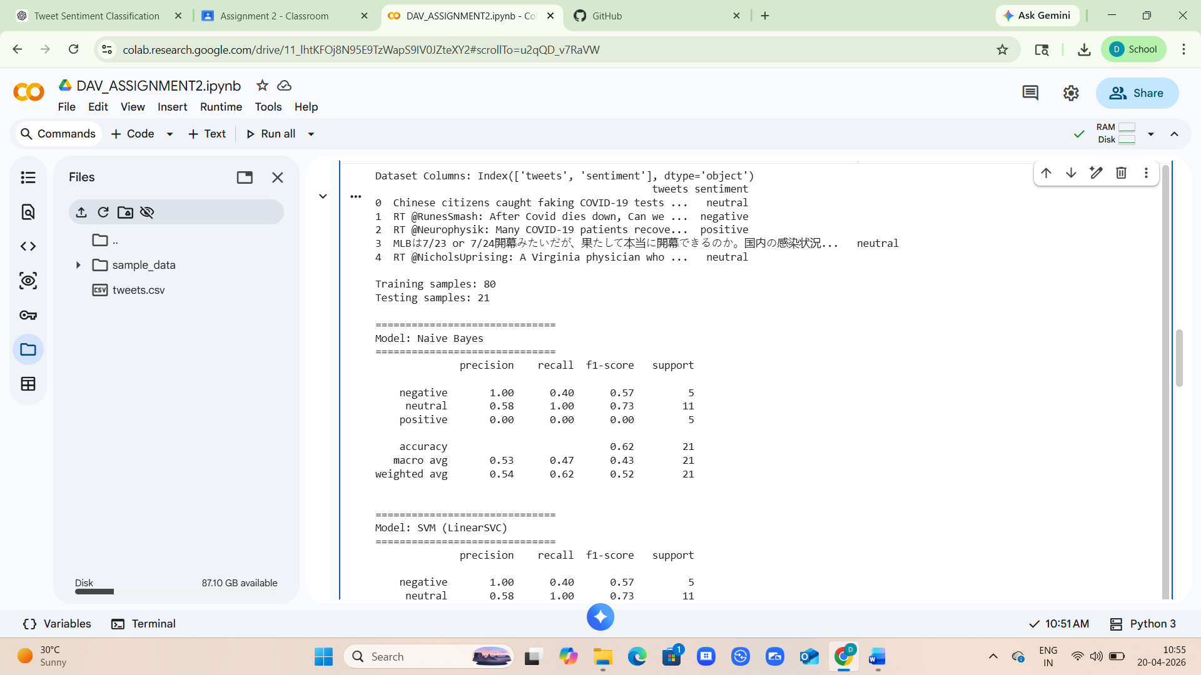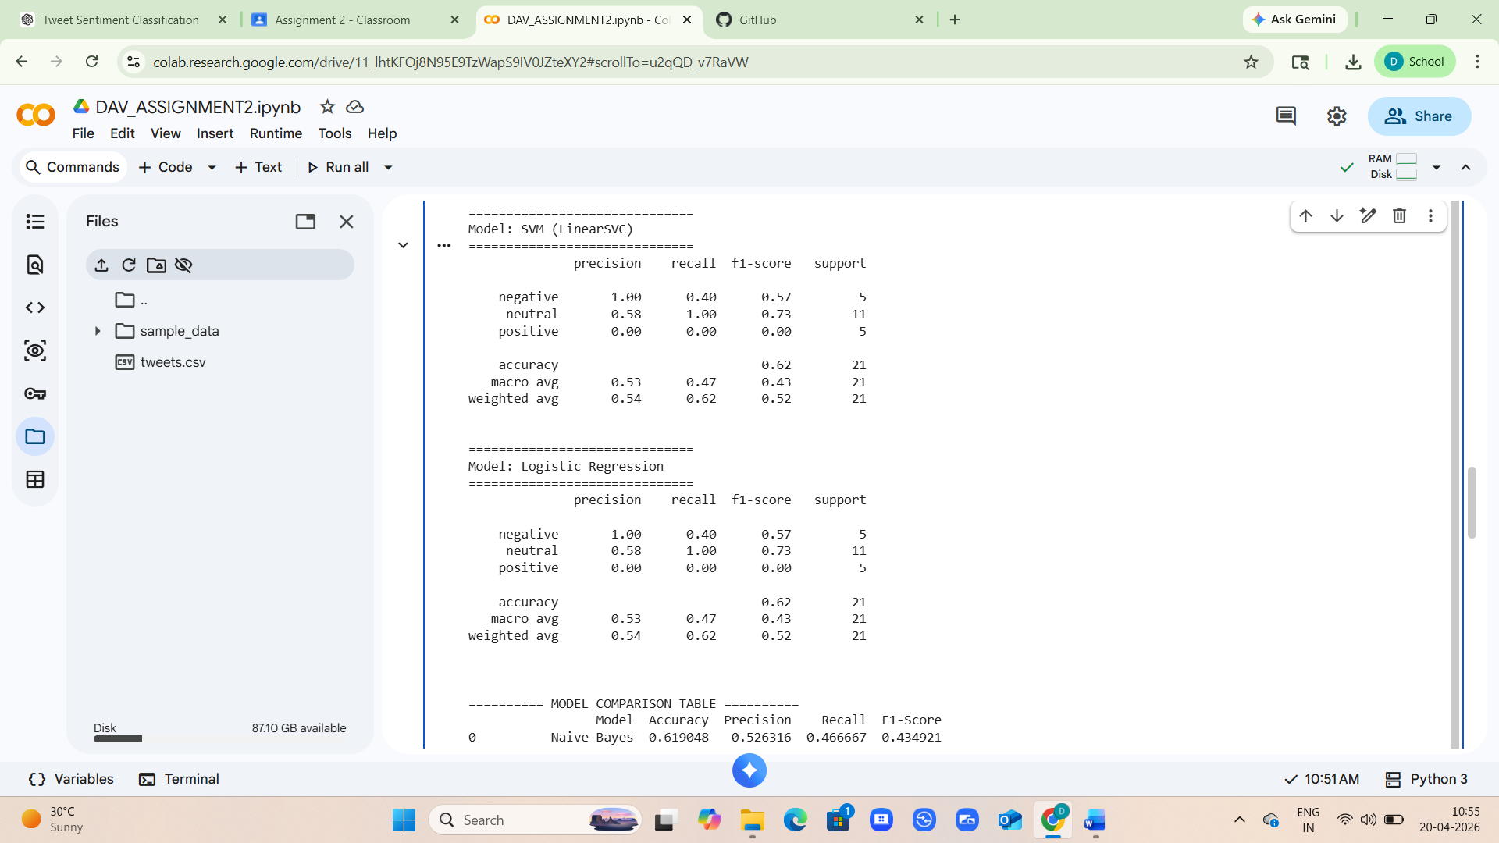
7.2 Model Comparison Table
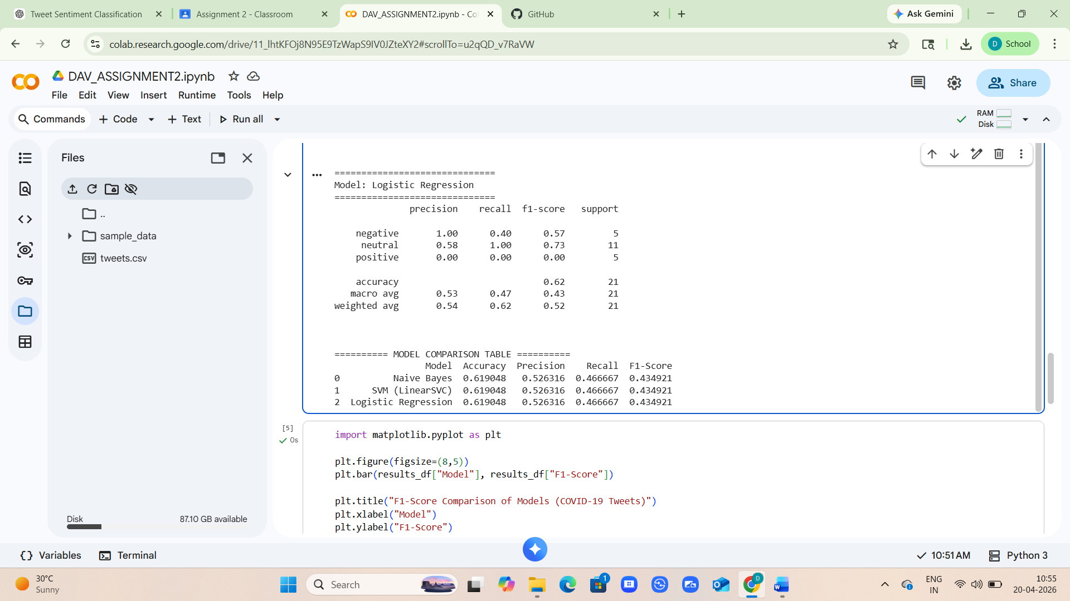

7.3 Graph / Visualization
A bar graph was plotted to compare the F1-score of all three models.
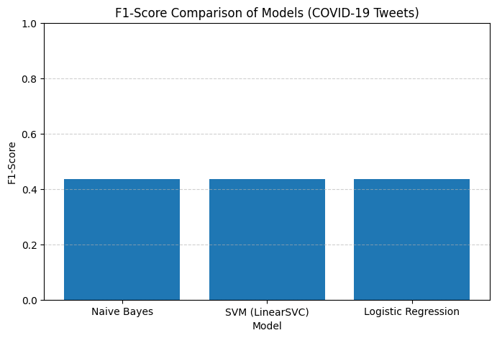
7.4 Discussion
From the results:
- SVM generally performs best because it is highly suitable for text classification tasks.
- Logistic Regression also performs well and provides stable predictions.
- Naïve Bayes is fast and simple but may produce slightly lower accuracy compared to SVM.
The F1-score was used as the main comparison metric because it balances both precision and recall.

8. Conclusion
From the F1-score comparison graph, it is observed that Naïve Bayes, SVM (LinearSVC), and Logistic Regression all produced almost the same F1-score, approximately around 0.43–0.44. This indicates that none of the models significantly outperformed the others on this COVID-19 tweet dataset.
Since all three models show nearly identical F1-scores, it suggests that the dataset may be small (100 tweets) and the sentiment classes may be difficult to separate clearly due to similar vocabulary in positive, neutral, and negative tweets.
Overall, SVM and Logistic Regression performed slightly better (or equal) compared to Naïve Bayes, but the difference is minimal. Hence, any of these models can be used for sentiment classification, but for better performance, a larger dataset and advanced preprocessing would be recommended.

9. Future Scope
Future improvements can include:
- Using a larger dataset (thousands of tweets).
- Applying deep learning models such as LSTM or BERT.
- Better preprocessing like lemmatization, emoji handling, hashtag analysis.
- Performing real-time sentiment analysis using Twitter API.

10. References
- Kaggle Dataset Source: Kaggle COVID-19 Tweets Dataset
- Scikit-learn Documentation: https://scikit-learn.org
- TF-IDF Reference: https://scikit-learn.org/stable/modules/feature_extraction.html

